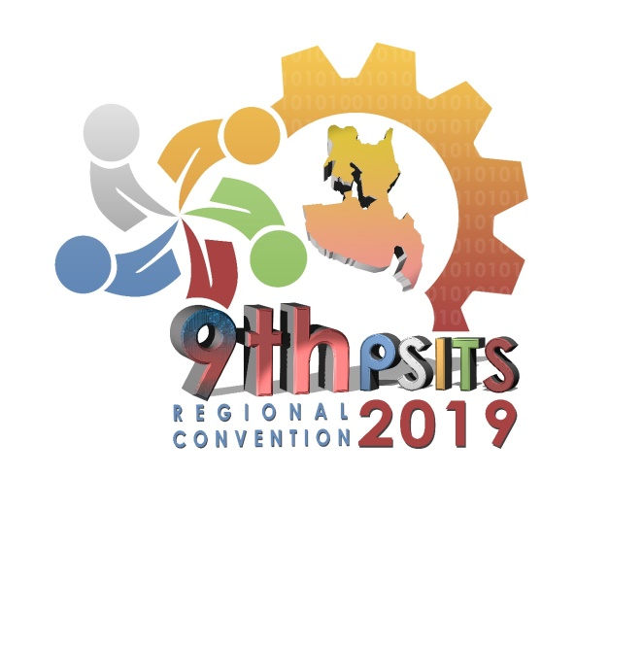

**List of Events**

* Research Presentation
* Capstone Project Presentation
* STEP IT Dance Competition
* Audio Visual Presentation Same Day Edit Competition
* Spot Music Video
* Quiz Bowl Contest
* Programming Competition
* Booth Installation Display
* Problem Analysis and Solution Making
* Infomercial
* E-poster Competition
* WACOM Digital Art Contest/ Composite Graphics Design
* E-Waste Installation Art Device (wall mounted)
* Uniform T-shirt Design
* #Q&A
* Futuristic Techno Attire